CK40N -

Functionality
The costing run enables to cost, analyze, mark and release more than one product at the same time.

Costing with quantity structure results in an explosion of the BOM and the derivation of activity prices from the routings and work centers to create a cost estimate for each product.

Marking the cost estimate results in the standard price becoming visible on the material master in the field Planned Price as the future standard price.

Releasing the cost estimate can occur once the period roll-over has happened and the standard price becomes the current valuation price of the product. A financial document is created for the valuation difference of stock. Every goods issue in the new period will effectively be valued against the new standard price.

Scenario
Mass costing run for all products that are valuated at standard price.

Requirements
Bill of Materials (BOM’s) must be maintained. Activity prices must exist as planned prices on the cost centers linked to Work Centers. Routings and activity types must be maintained.

Menu Path | Accounting → Controlling → Product Cost Controlling → Product Cost Planning → Material Costing → CK40N - Edit Costing Run
Transaction Code | CK40N

1. Double click on CK40N - Edit Costing Run.

Edit Costing Run

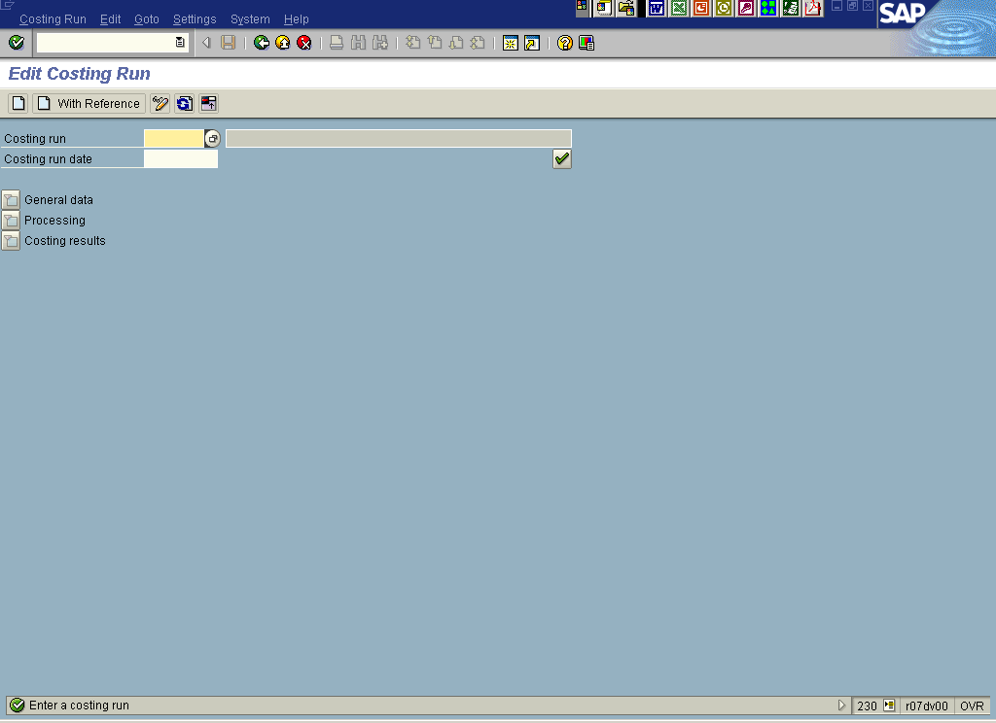

2. Click the Create button.

Create Costing Run

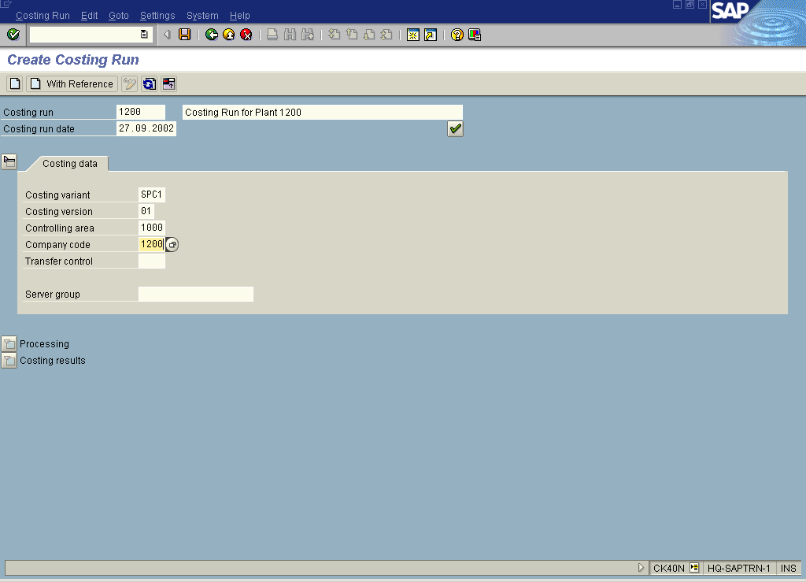
Note: In case of Costing variant SPC2 ( Group Valuation) & SPC3 ( Profit Center Valuation) you are not supposed to specify company code.
3. Update the following fields:

Field Name | Description | Values
Costing run | Costing run name | Example: 1200
Costing run | Costing run description | Example: Costing Run for Plant 1200
Costing run date | Costing run date of creation | Example: 27.09.2002
Costing variant | Costing variant for SABIC Legal Valuation | Example: SPC1
Costing version | Costing version (always use this value) | Example: 01
Controlling area | SABIC Controlling Area. | Example: 1000
Company Code | SABIC legal entity for which costing is carried out. | Example: 1200

4. Click the Enter button.
Create Costing Run

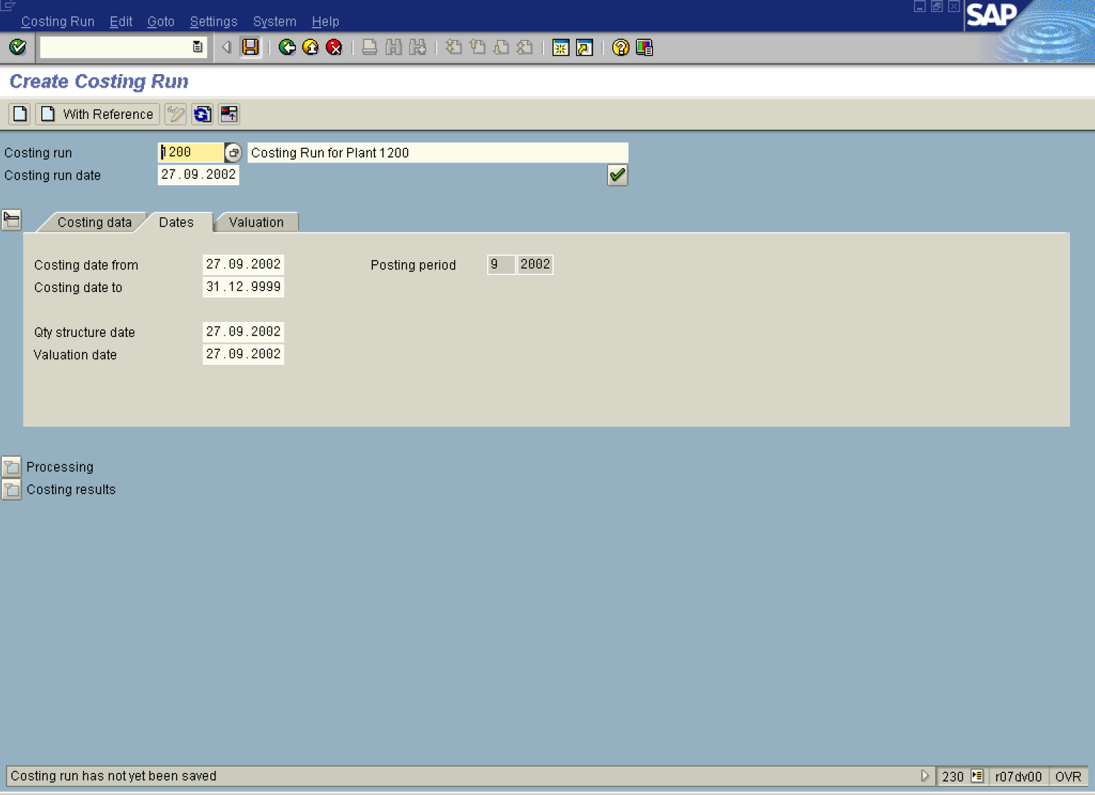
Note: Check posting period specified in the field 'Posting period'. Stock will be revaluated for this period.

5. Update the following fields:

Field Name | Description | Values
Costing date from | Description of the Costing date from. | Example: 27.09.2002
Qty structure date | Description of the Qty structure date. | Example: 27.09.2002
Valuation date | Description of the Valuation date. | Example: 27.09.2002
6. Click the Enter button.
7. Click the Save button.

Edit Costing Run

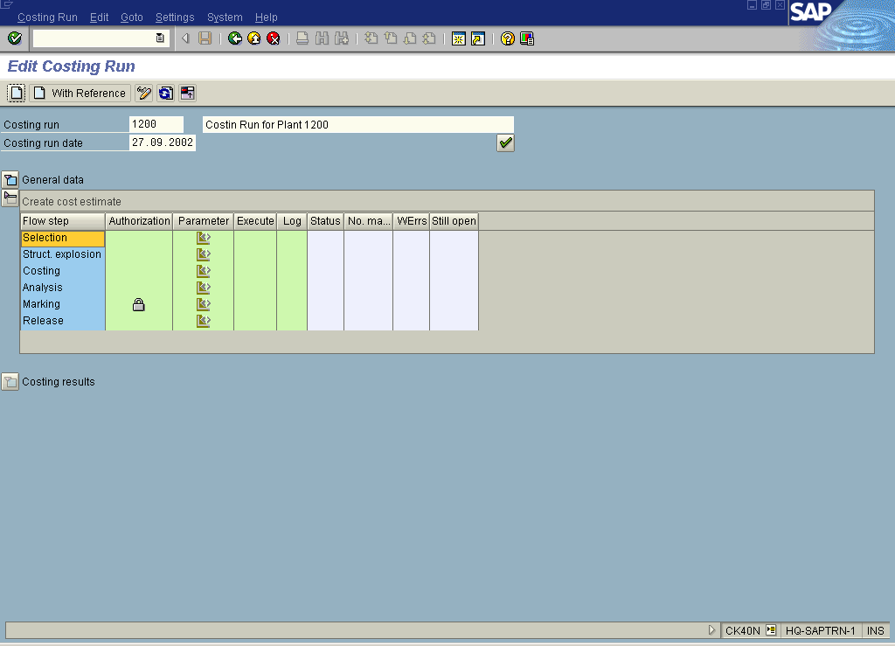

8. Click the Selection Parameter button.

Costing Run: Selection - Change Parameters

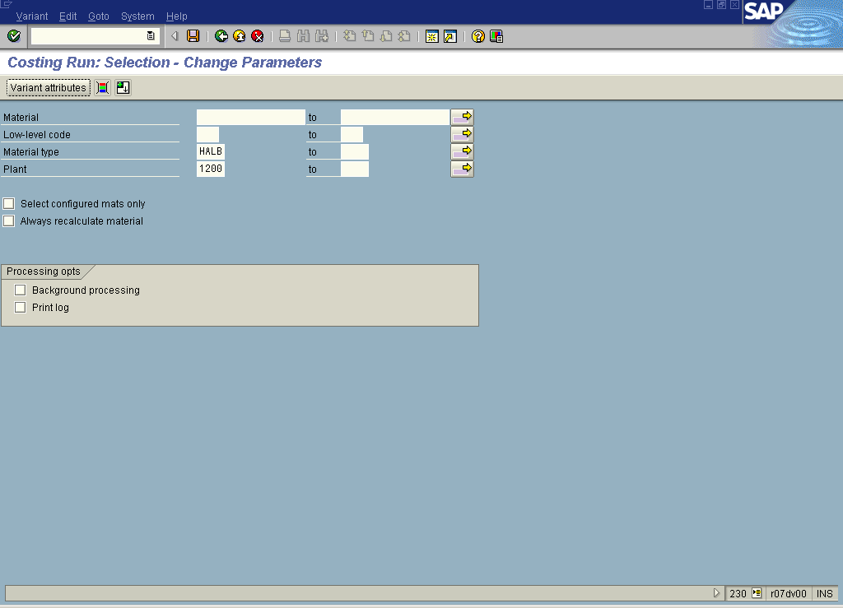

9. Update the following fields:

Field Name | Description | Values
Material Type | Code identifying the material type Eg Semi-finished & Finished goods. | Example: HALB
Plant | Code identifying the operational unit of the company where the material is manufactured and stored | Example: 1200

10. Click the Background processing to deselect.
11. Click the Save button.
12. Click the Back button.
Edit Costing Run

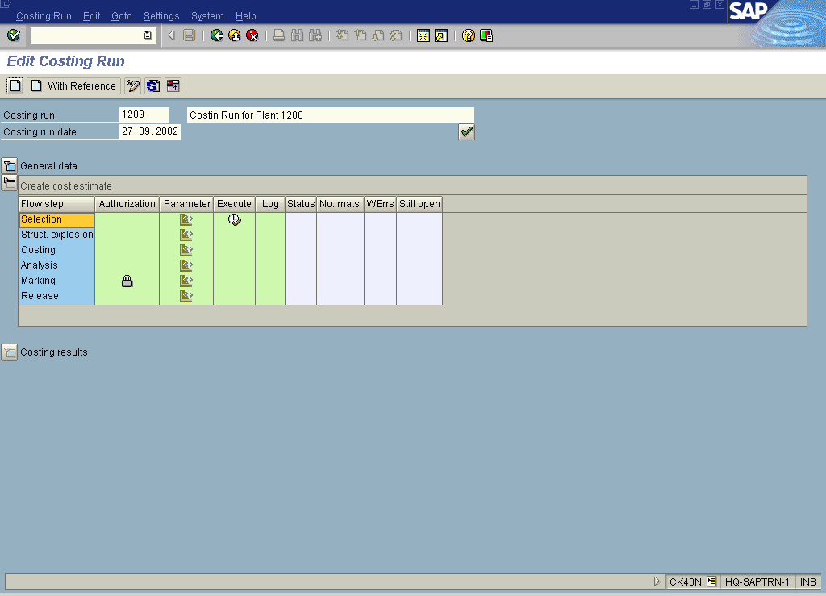

13. Click the Selection Execute button.
Edit Costing Run

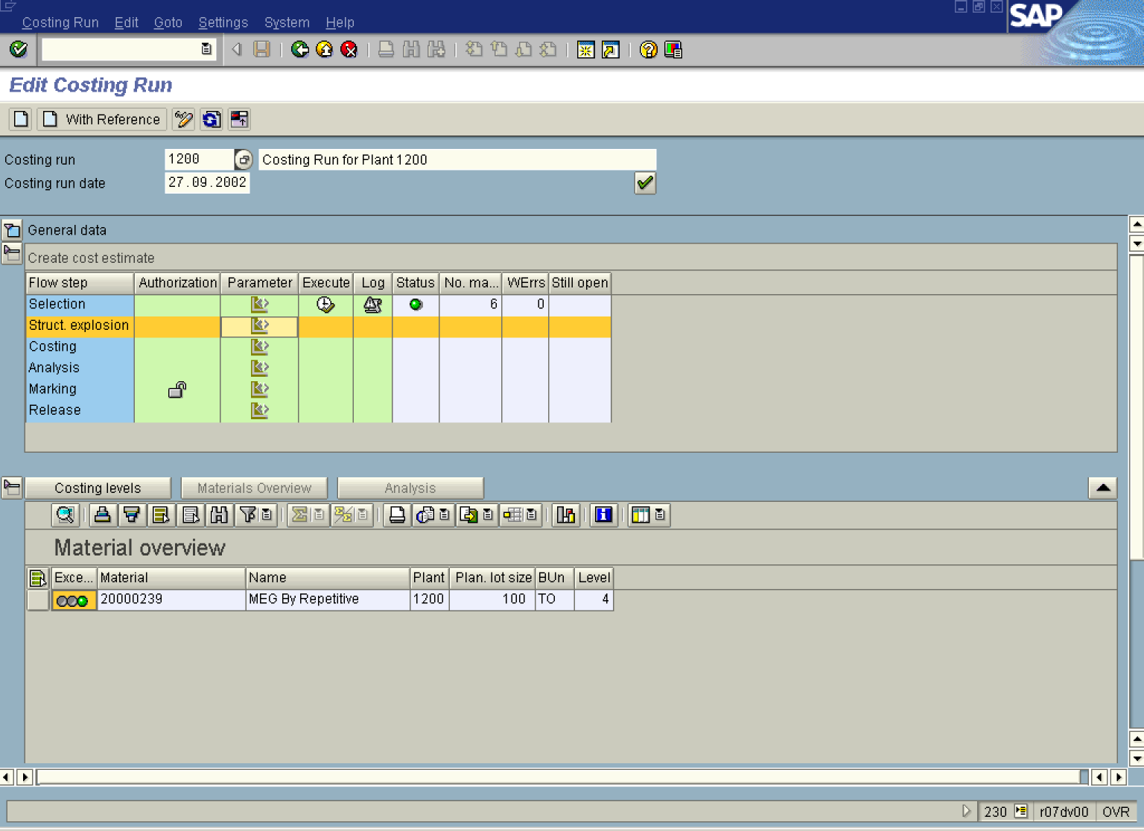

14. Click the Costing results Collapse button.

15. Click the Materials Overview button.

16. Click the Struct. explosion Parameter button.

Costing Run: BOM Explosion - Change Parameters

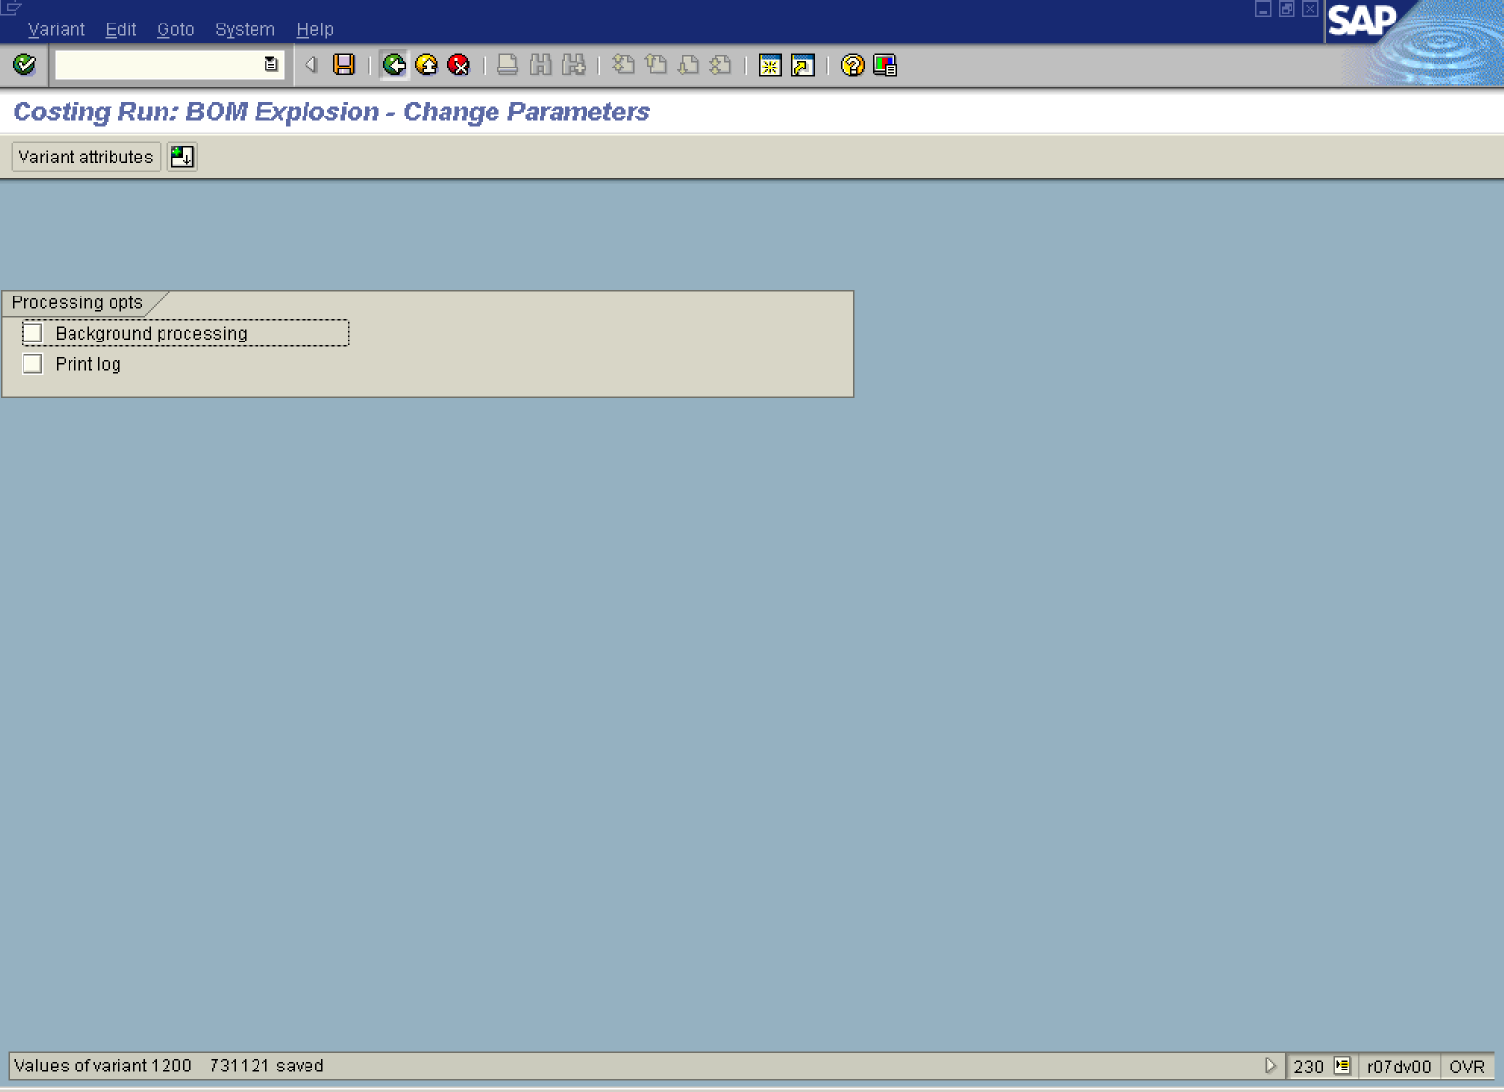

17. Click the Background processing to deselect.

18. Click the Save button.

19. Click the Back button.

Edit Costing Run

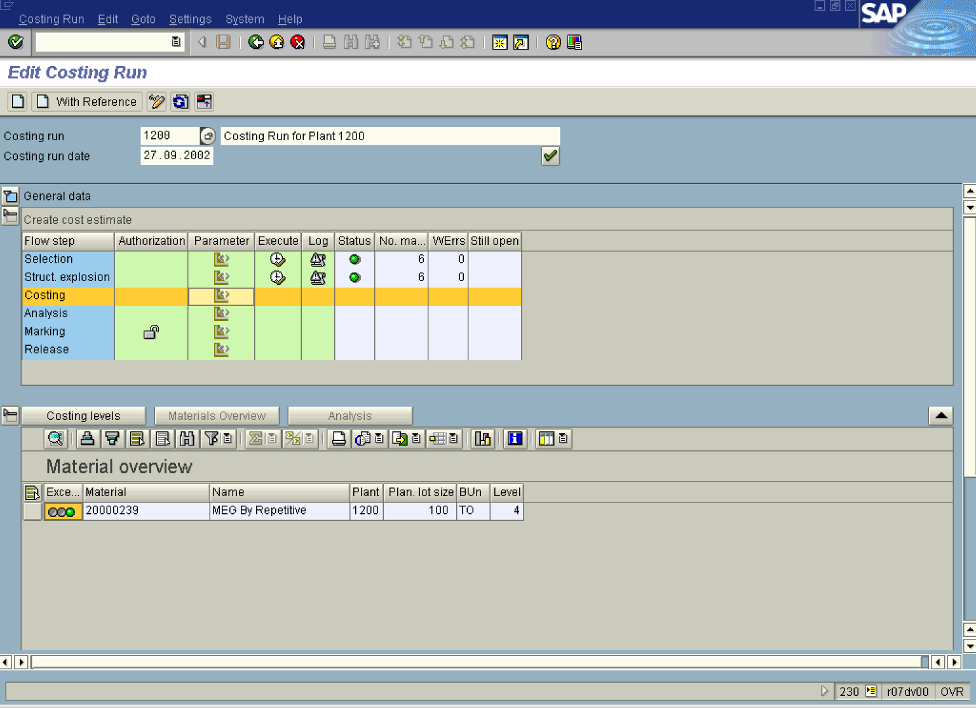

20. Click the Struct. explosion Execute button.

21. Click the Materials Overview button.

22. Click the Costing Parameter button.

Costing Run: Cost Estimate - Change Parameters

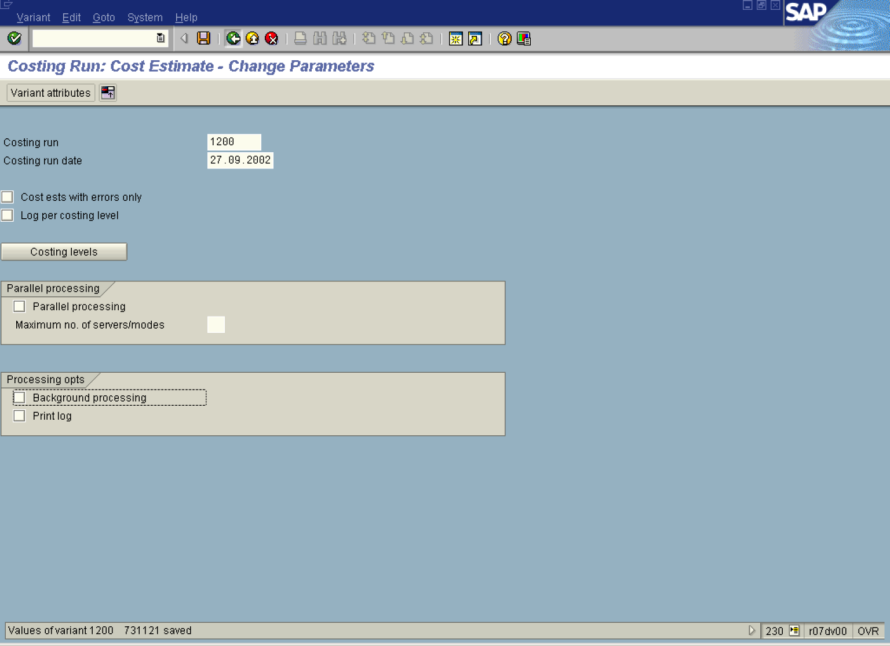

23. Click the Background processing to deselect.

24. Click the All selections button.

25. Click the Save button.

26. Click the Back button.

Edit Costing Run

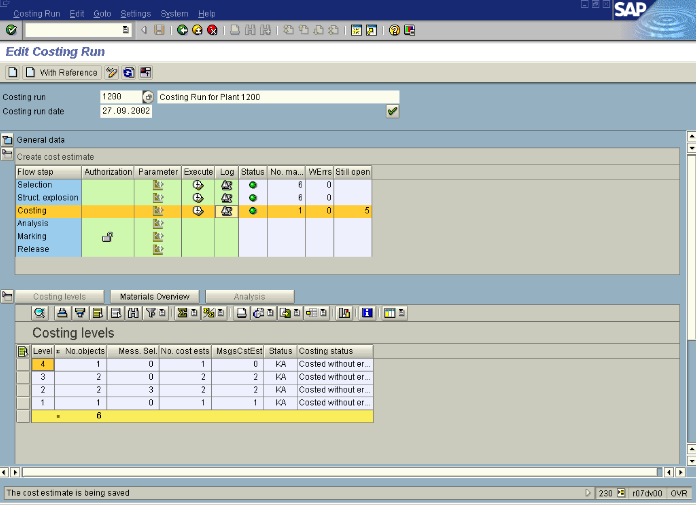

27. Click the Costing Execute button.

28. Click the Costing Log button.

Costing Run: Cost Estimate - Log

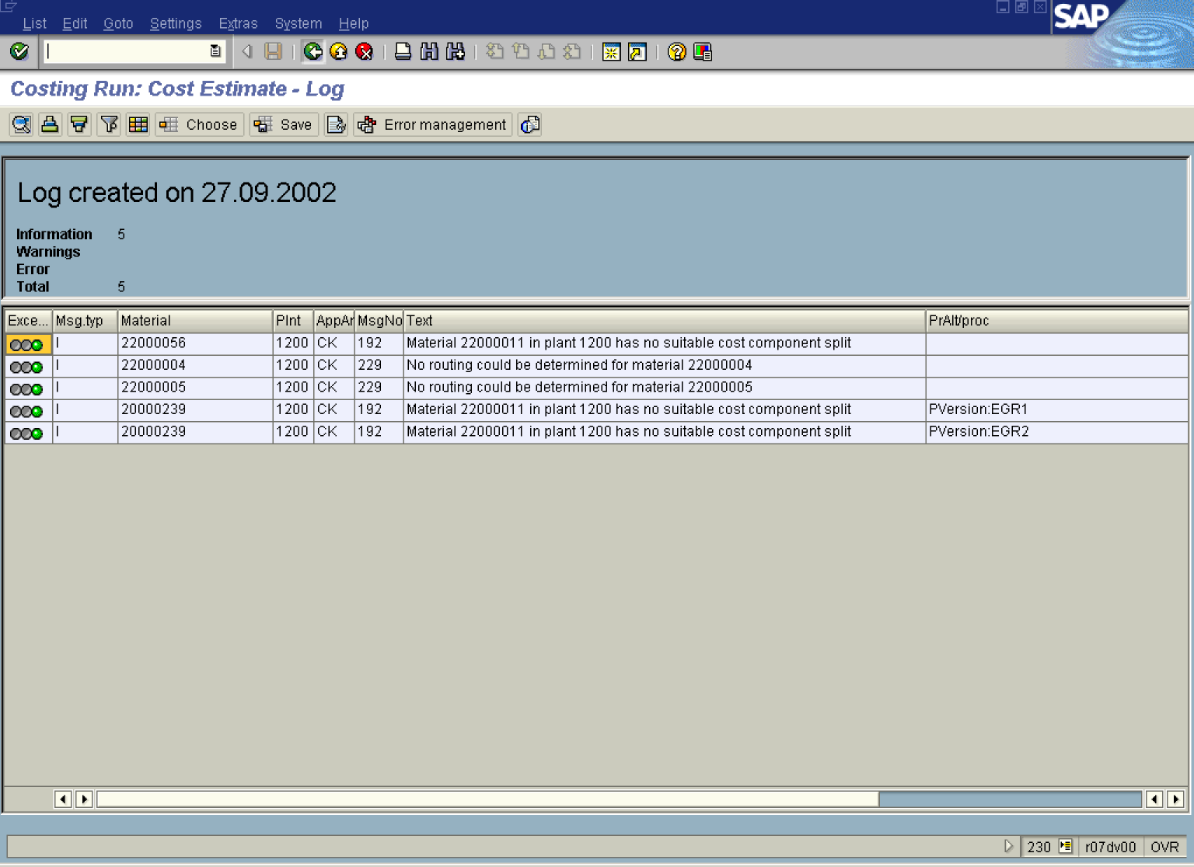

29. Click the Back button.

Edit Costing Run

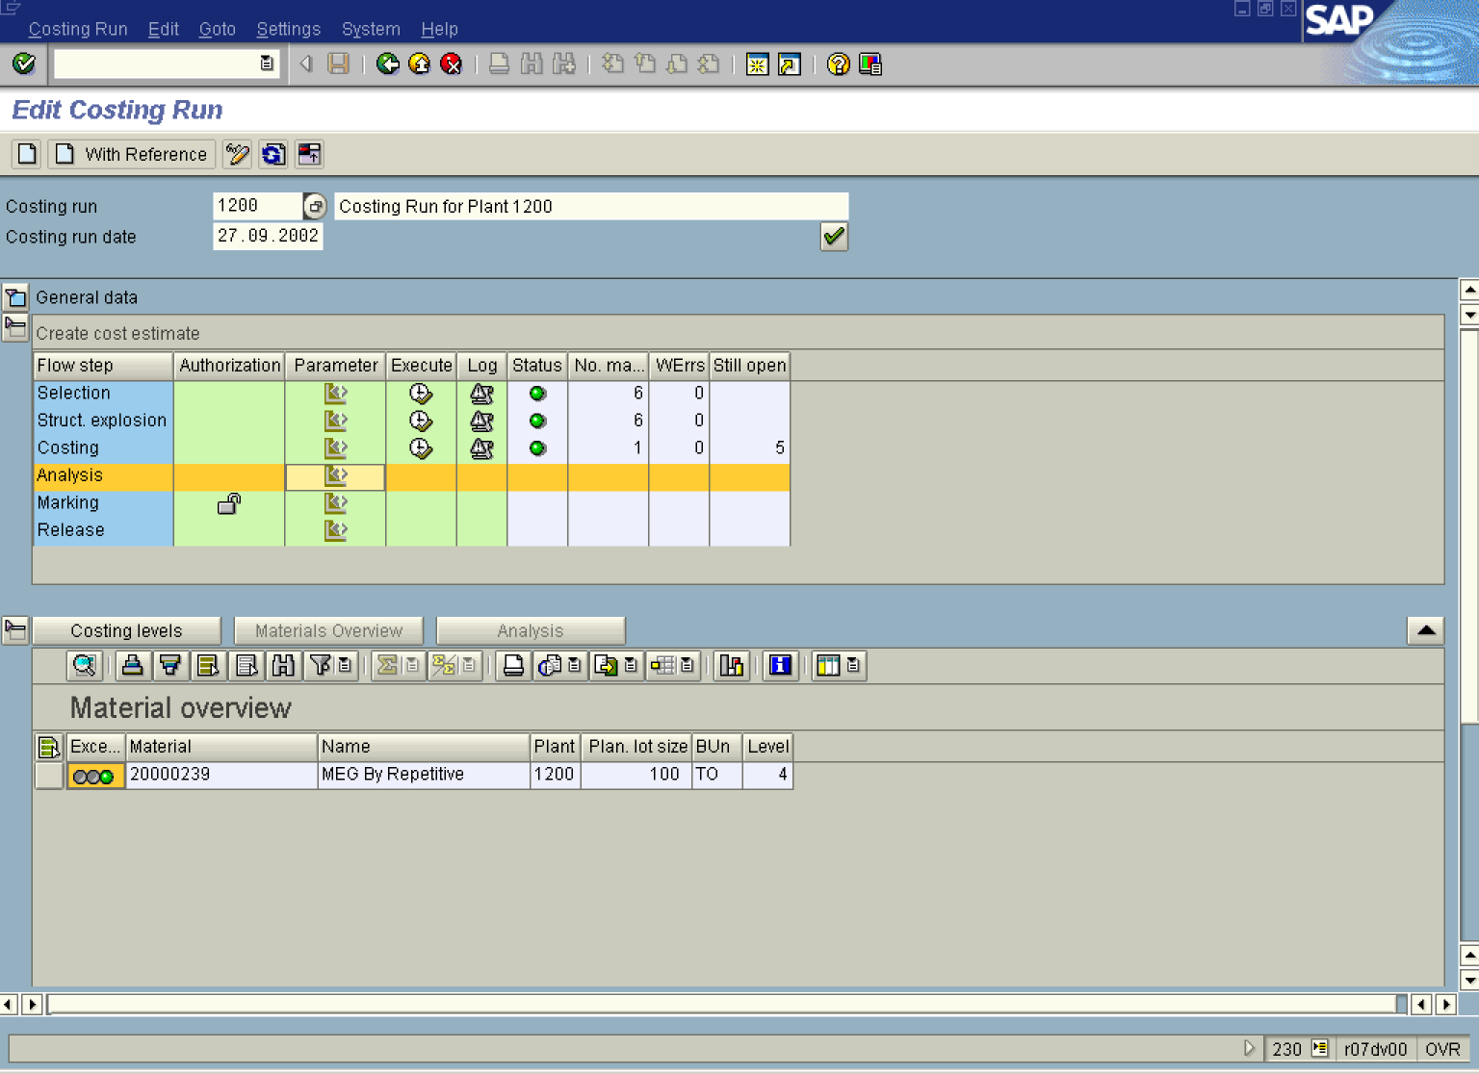

30. Click the Materials Overview button.

31. Click the Analysis Parameter button.

Choose reference for selection parameter

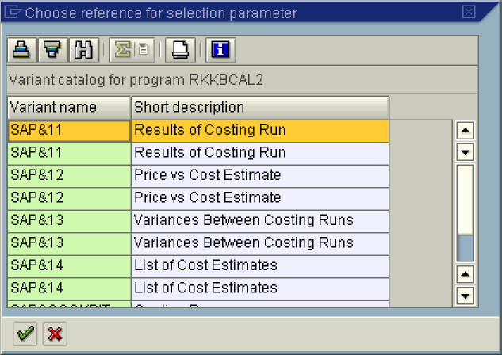

32. Select the SAP&11 - Results of Costing Run in list box.

Costing Run: Analysis - Change Parameters

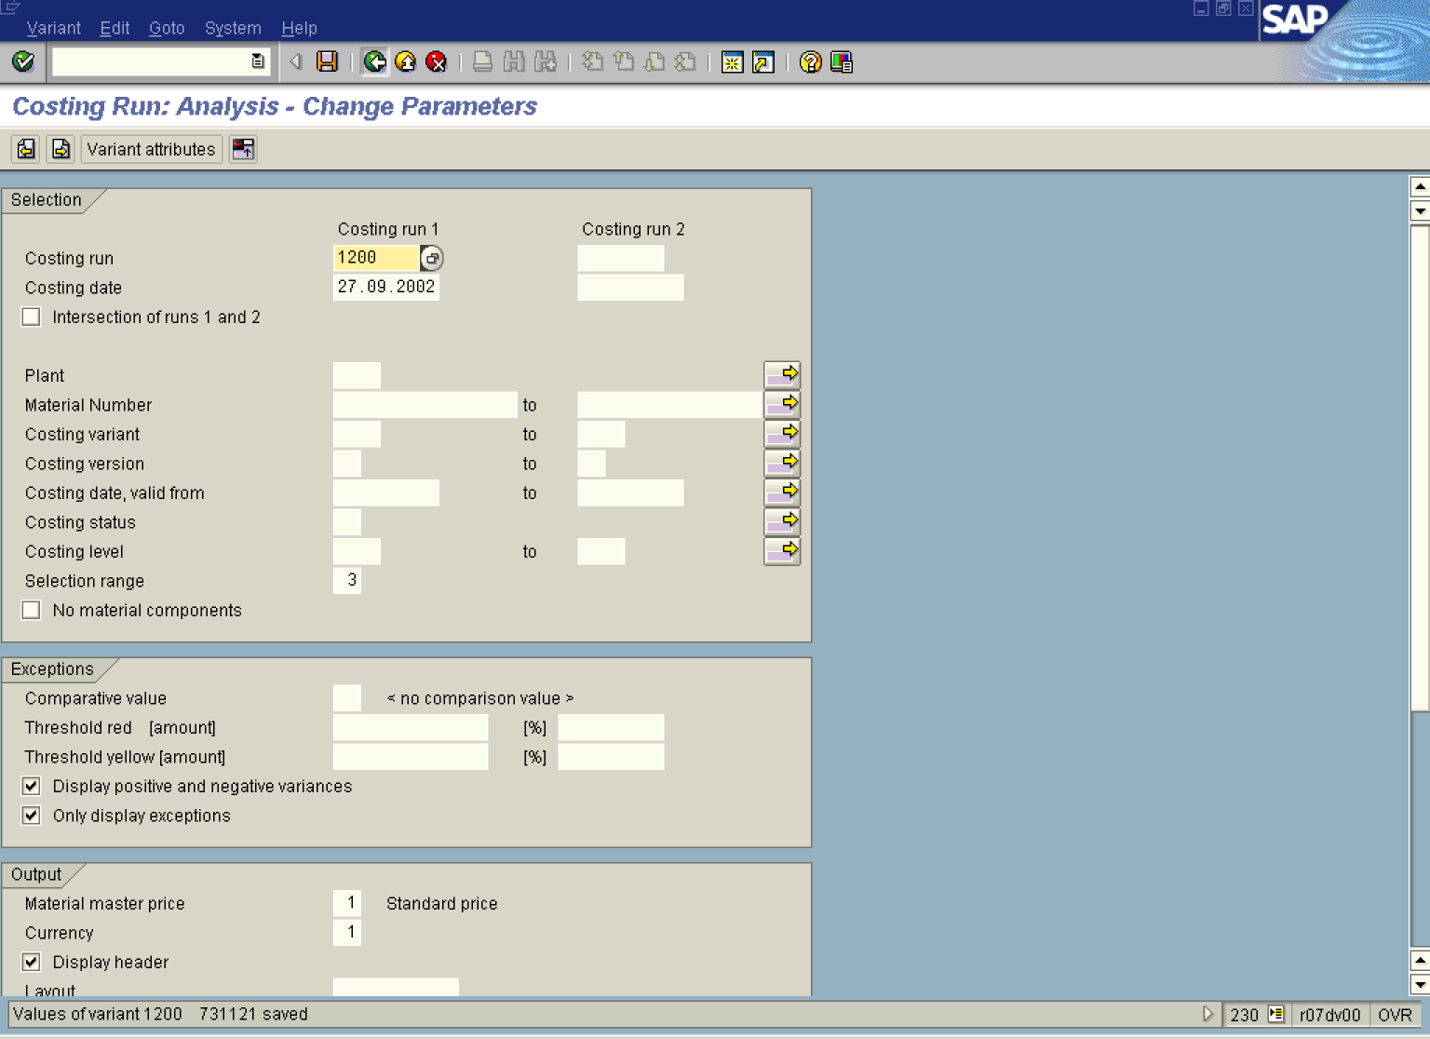

33. Click the All selections button.

34. Click the Save button.

35. Click the Back button.

Edit Costing Run

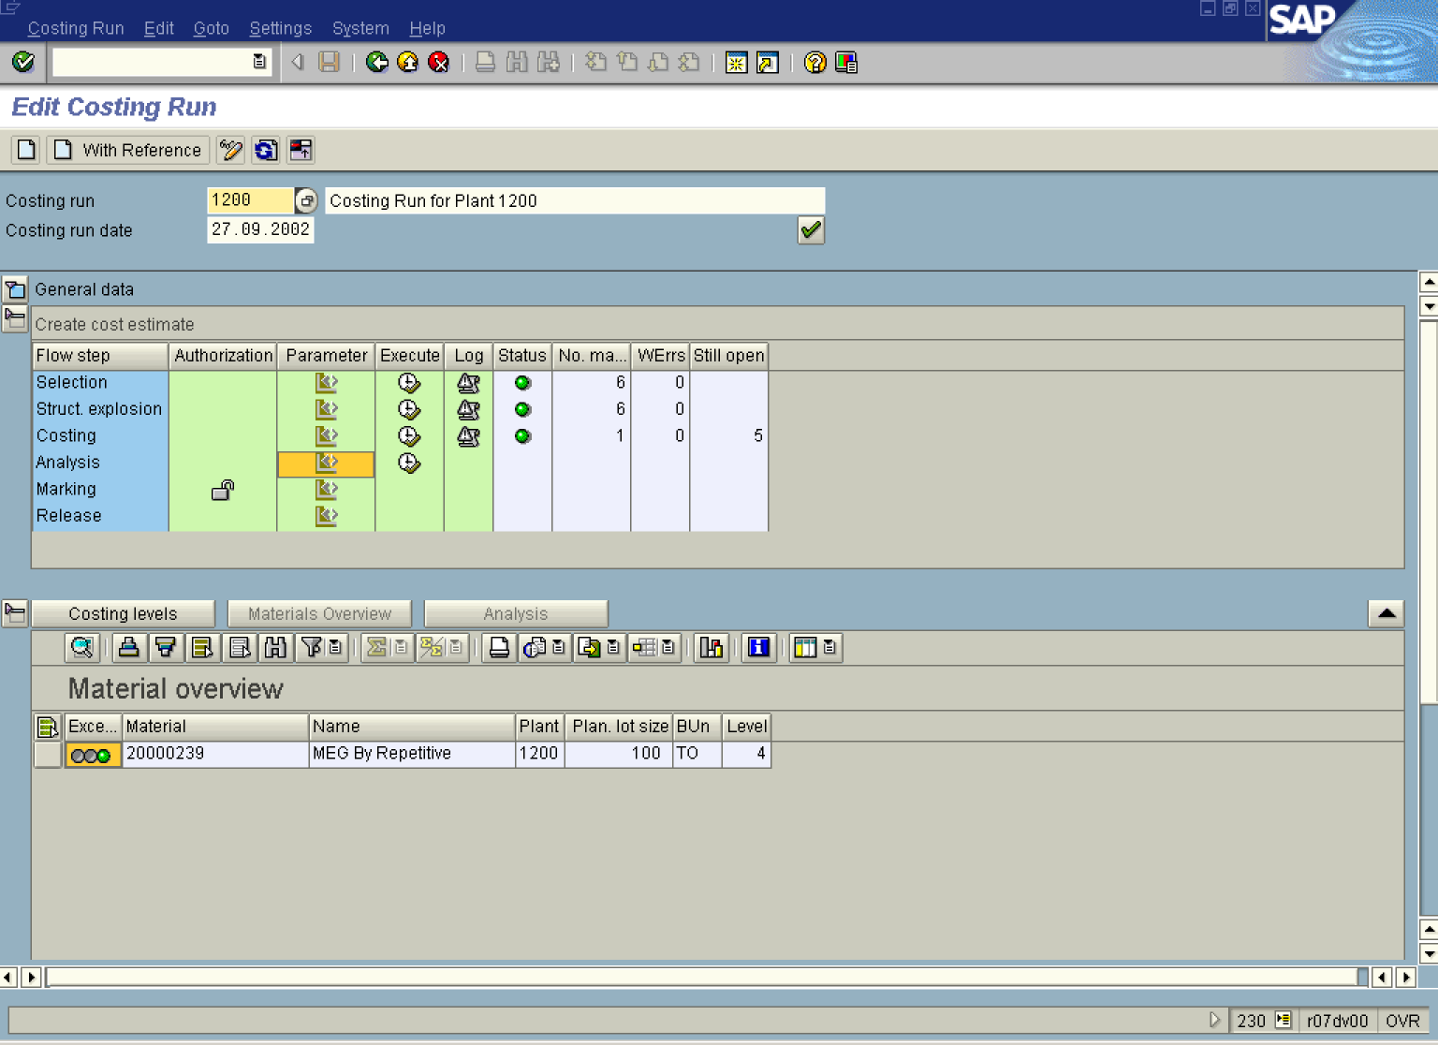

36. Click the Analysis Execute button.

Analyze/Compare Material Cost Estimates

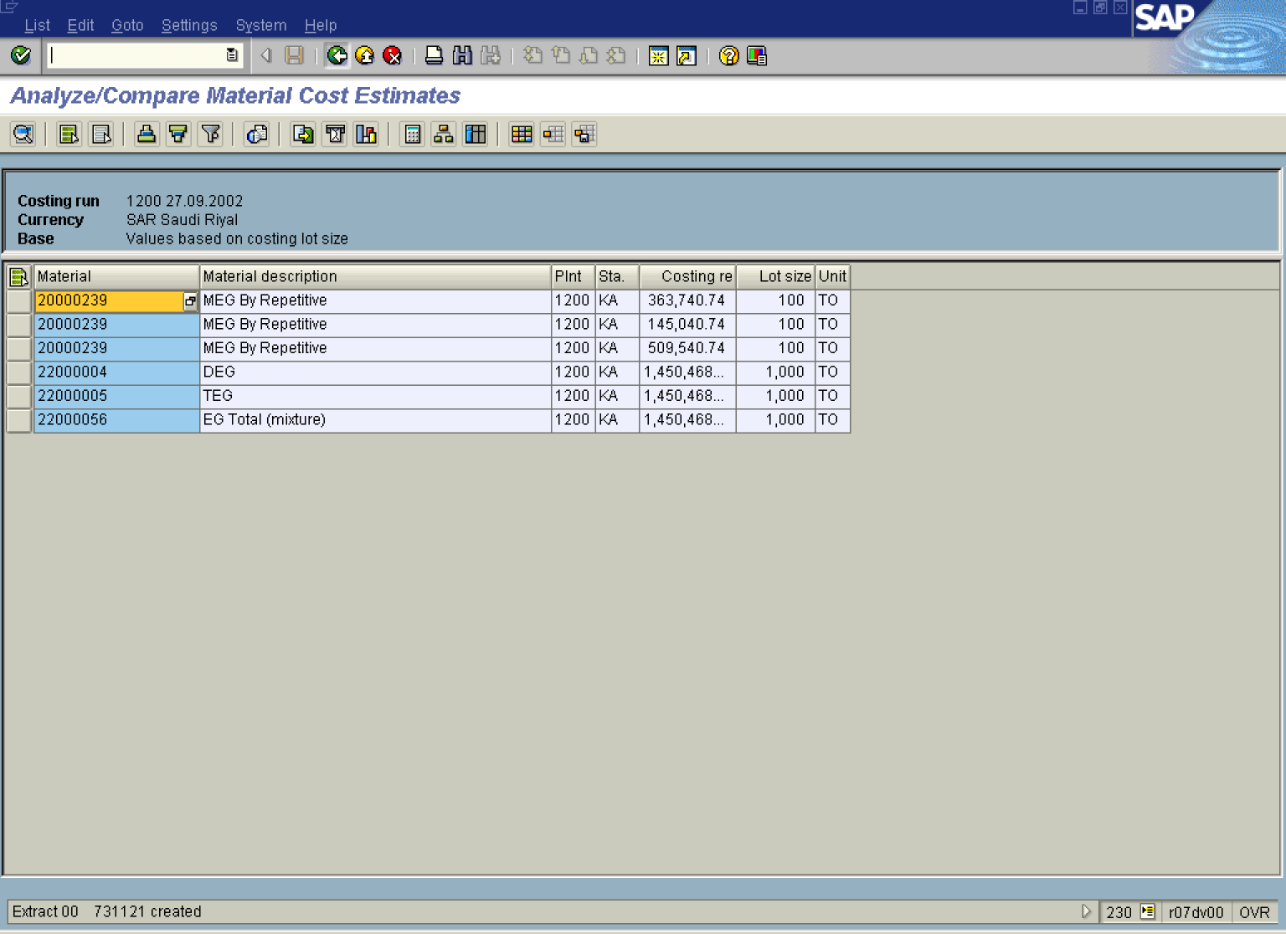

Note: To display detailed report with cost estimate of particular material click on the Detail report: cost estimate button.
37. Click the Back button.
Exit list

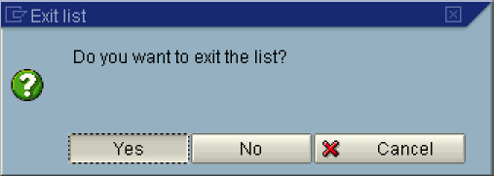

38. Click the Yes button.

Edit Costing Run

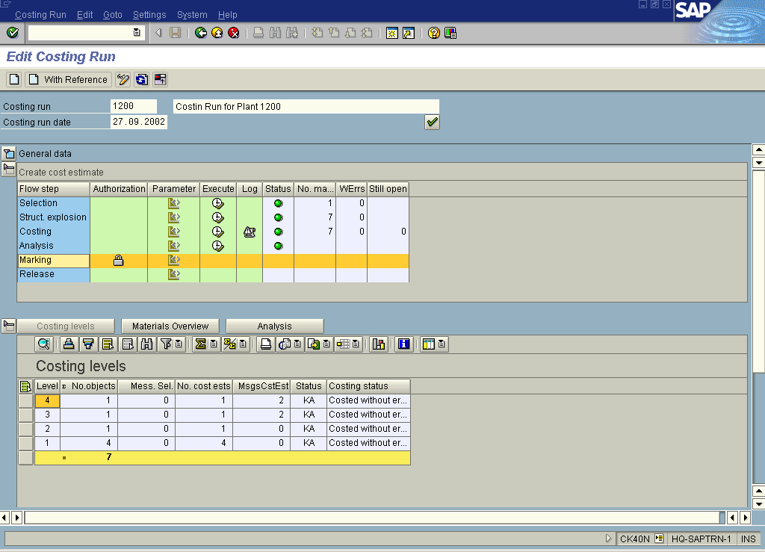

39. Click the Marking Padlock button to allow marking.

Price Update: Organizational Measure

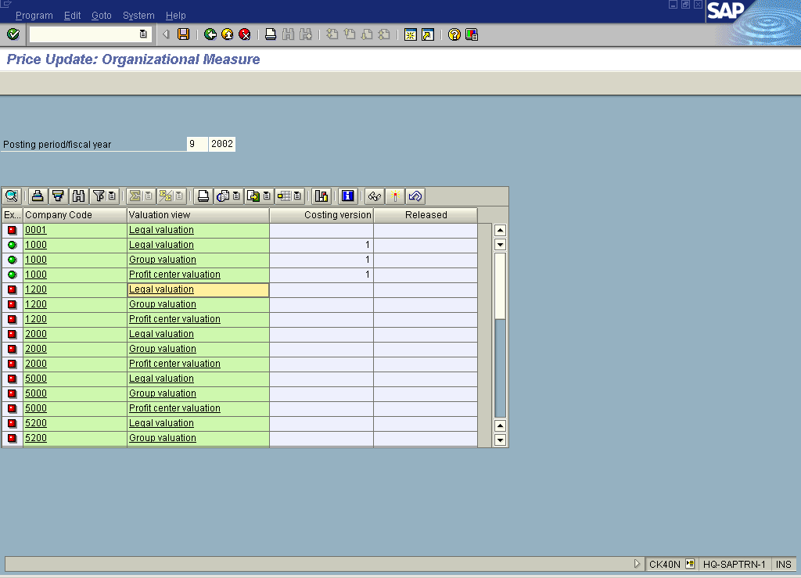

40. Select the 1200 Legal valuation line and click the Issue marking allowance button.

Note: To allow marking for Group valuation and Profit center valuation you should follow the step described above.

Permitted std. cost est. variant

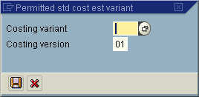

41. Click the Costing variant Drop-down list button to select an entry.

Permitted std. cost est. variant

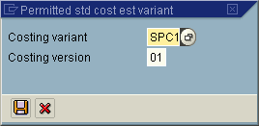

42. Click the Save button.

Price Update: Organizational Measure

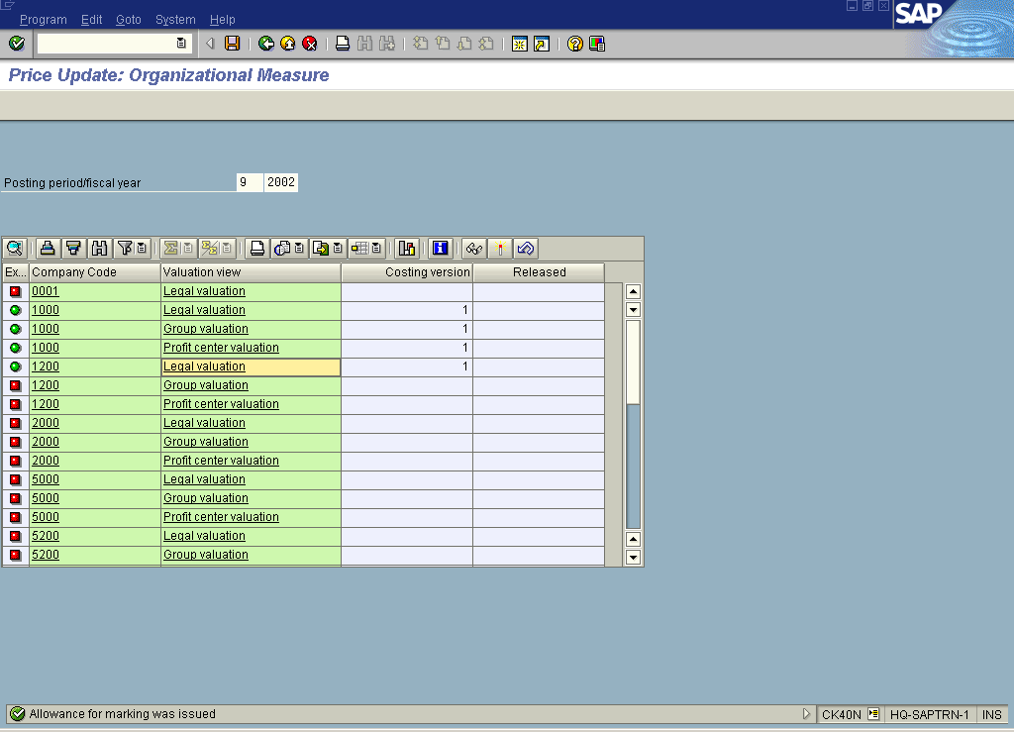

43. Click the Back button.

Edit Costing Run

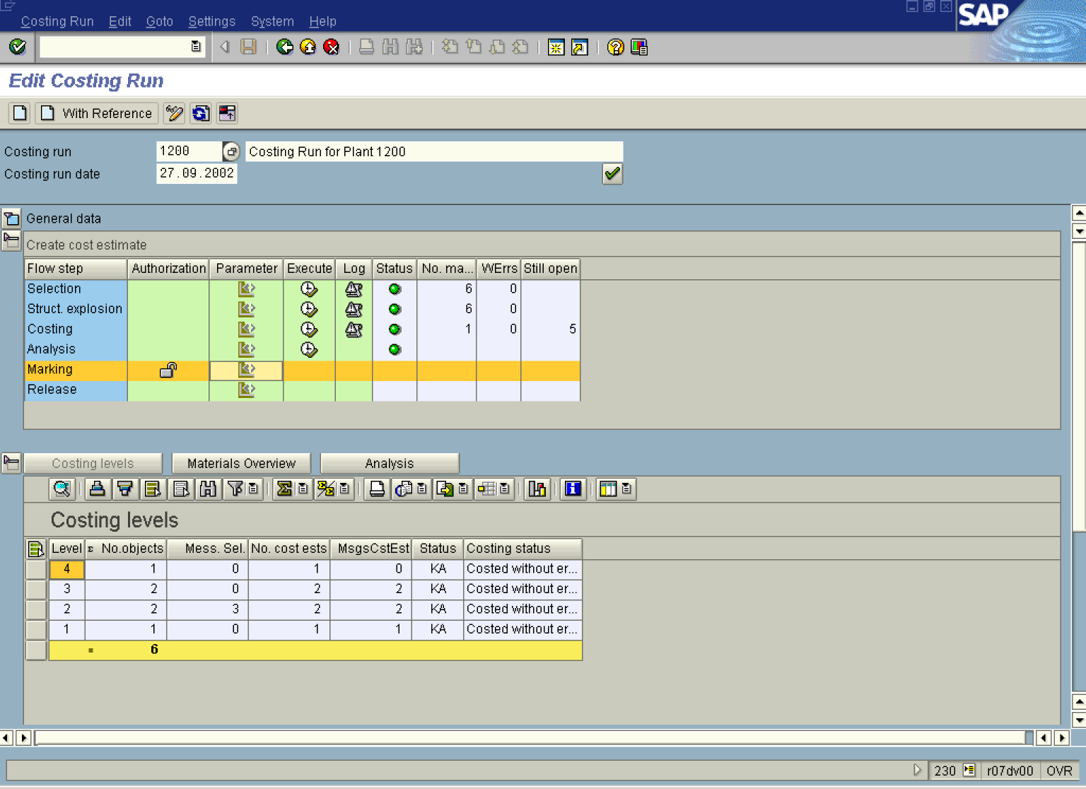

44. Click the Marking Parameter button.

Price Update: Mark Standard Price

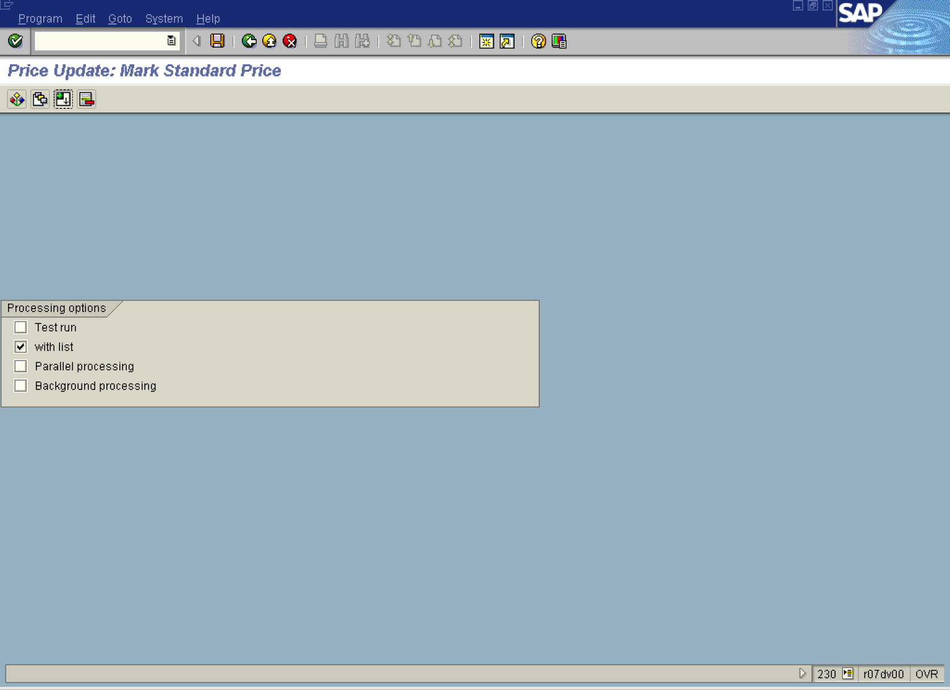

45. Click the Test run button to deselect.

46. Click the Background processing to deselect.

47. Click the All selections button.

Costing Run: Marking - Change Parameters

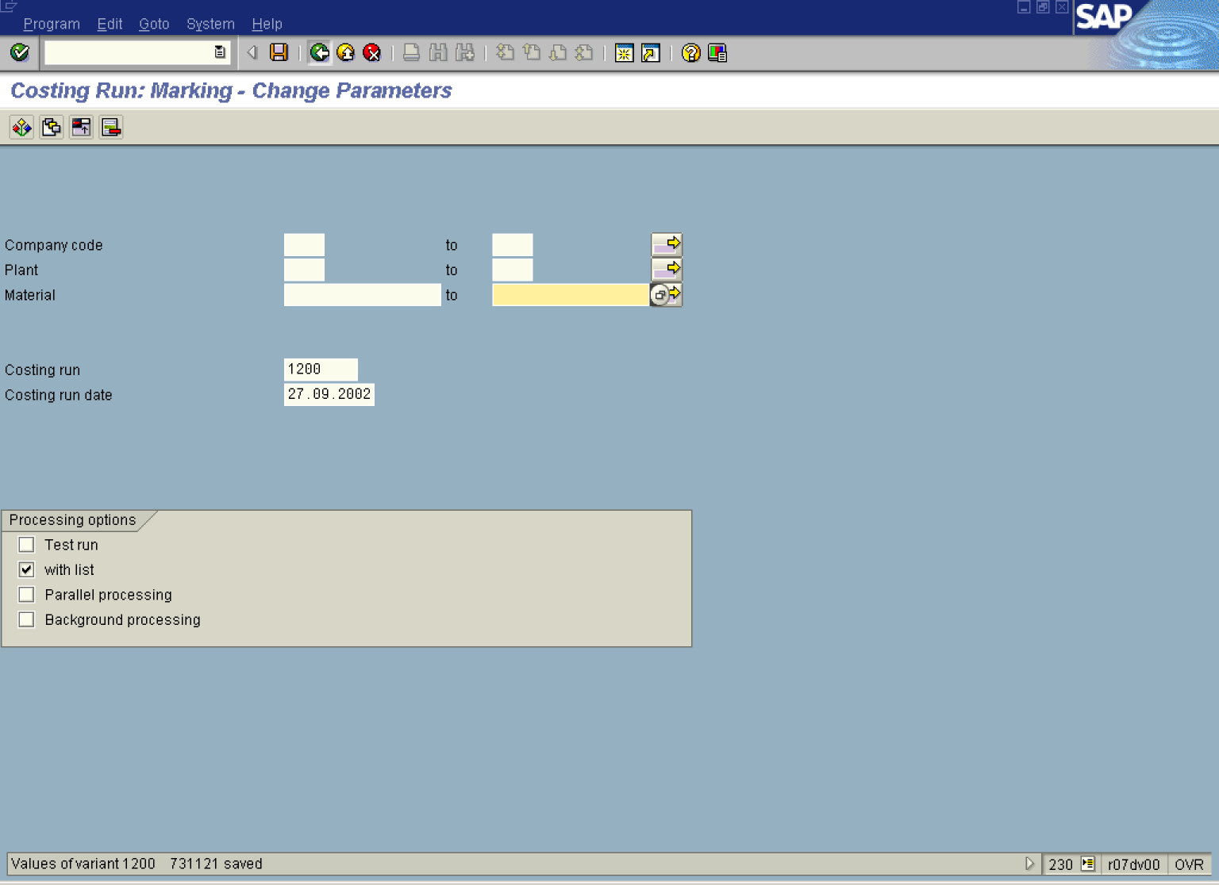

48. Click the Save button.

49. Click the Back button.

Edit Costing Run

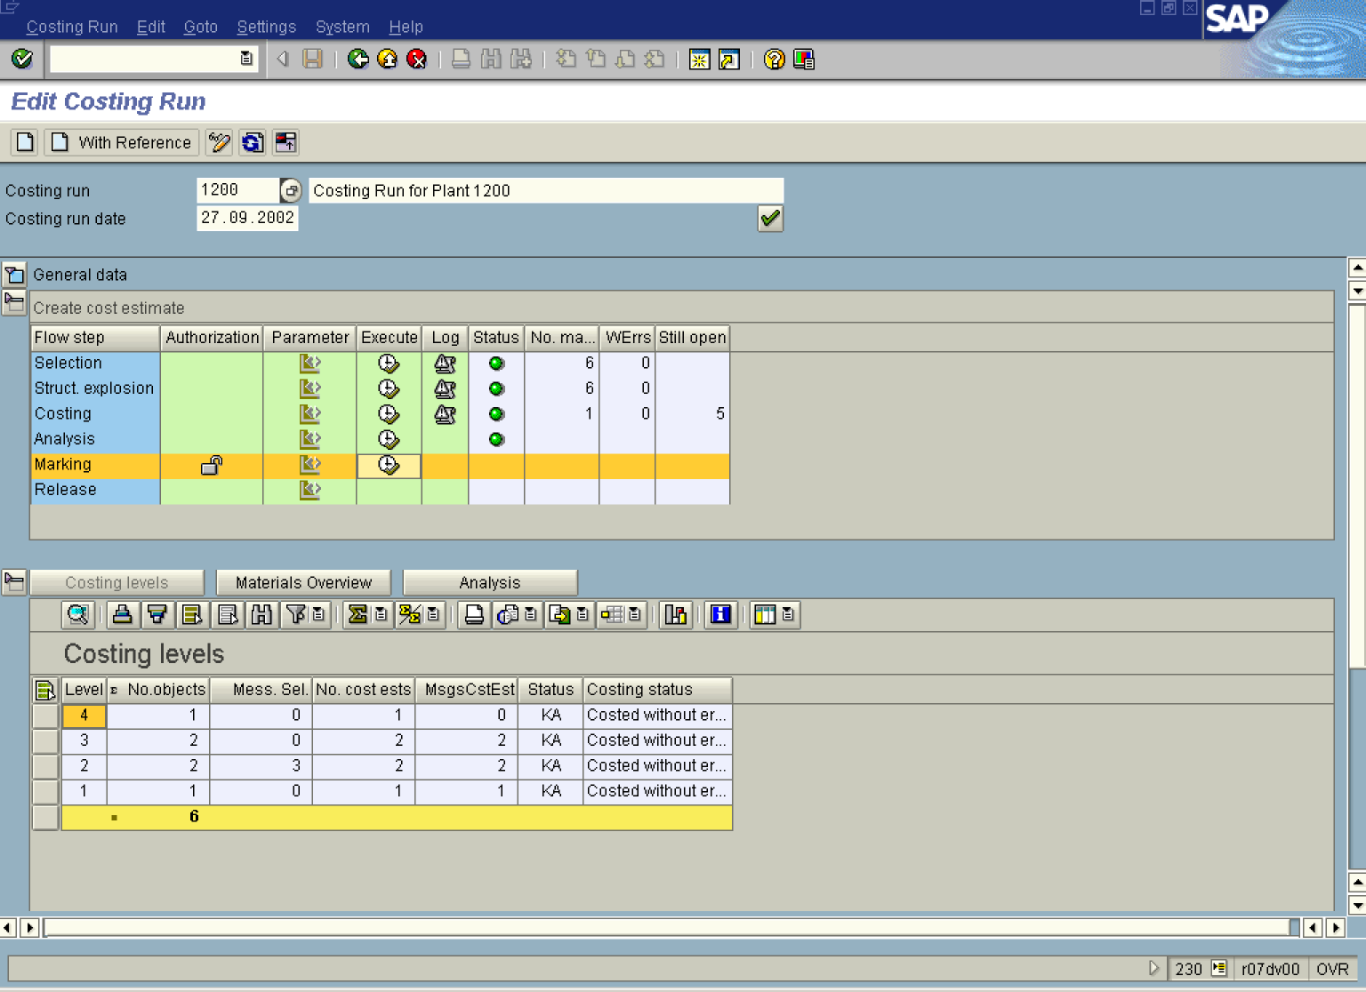

50. Click the Marking Execute button.

Price Update: Mark Standard Price

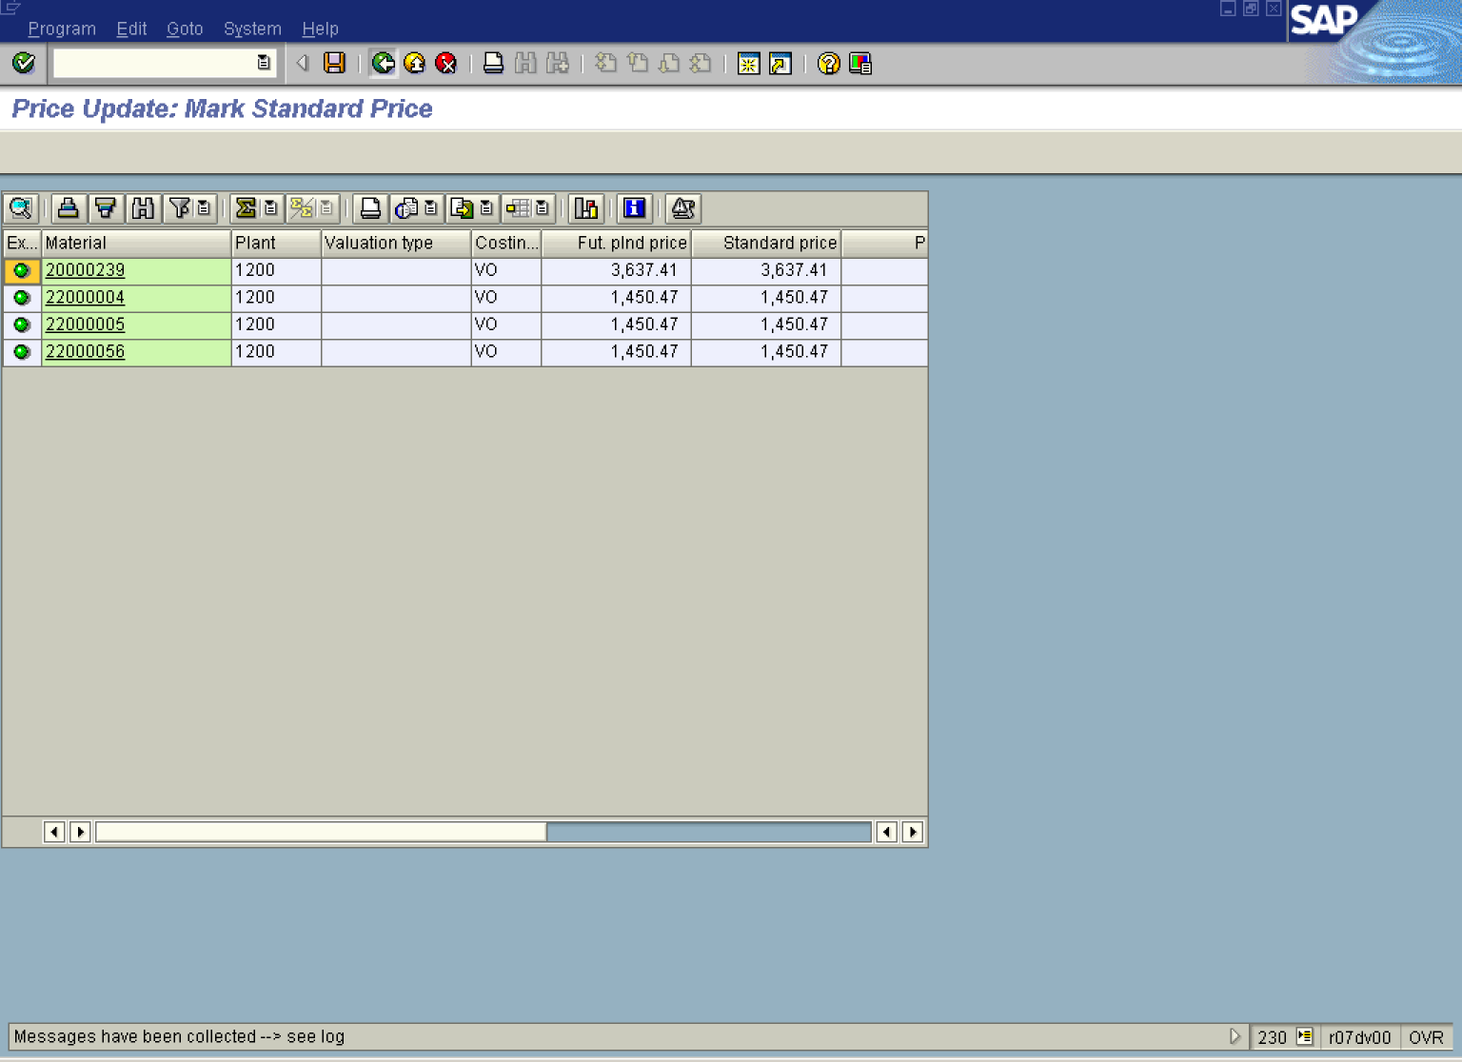

51. Click the Back button.

Edit Costing Run

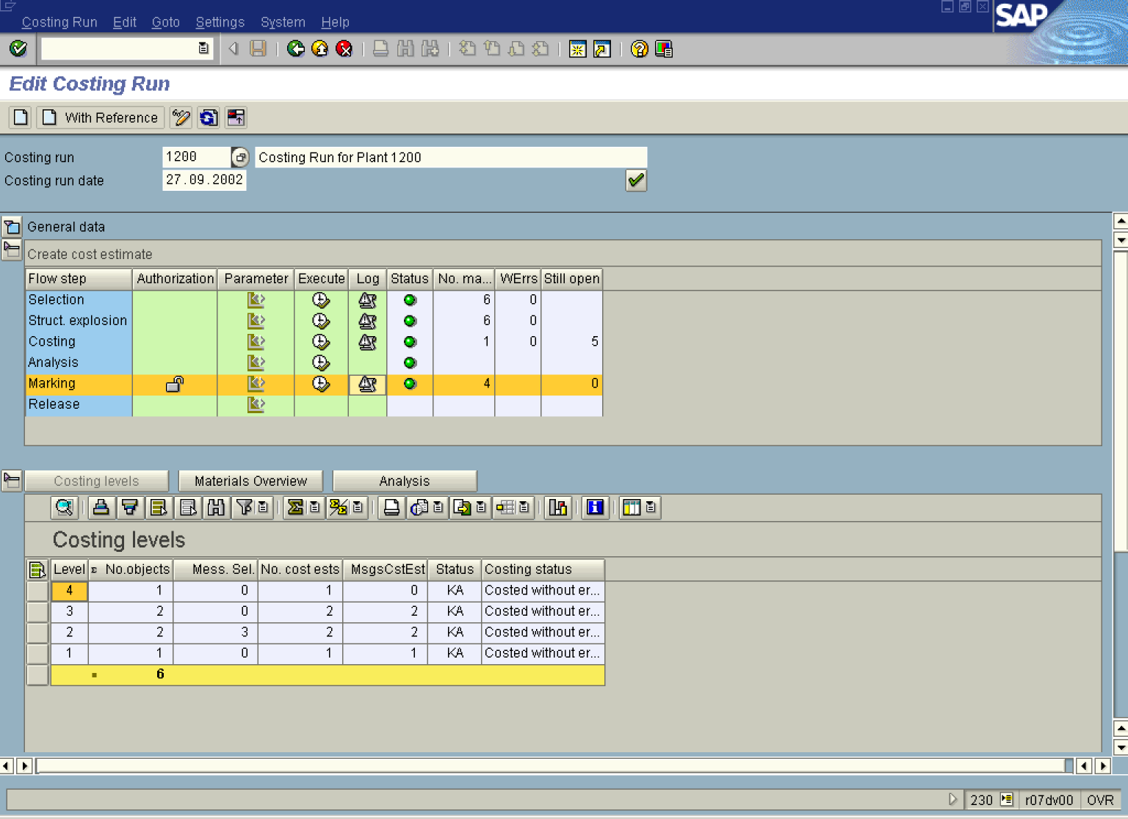

52. Click the Marking Log button.

Costing Run: Marking - Log

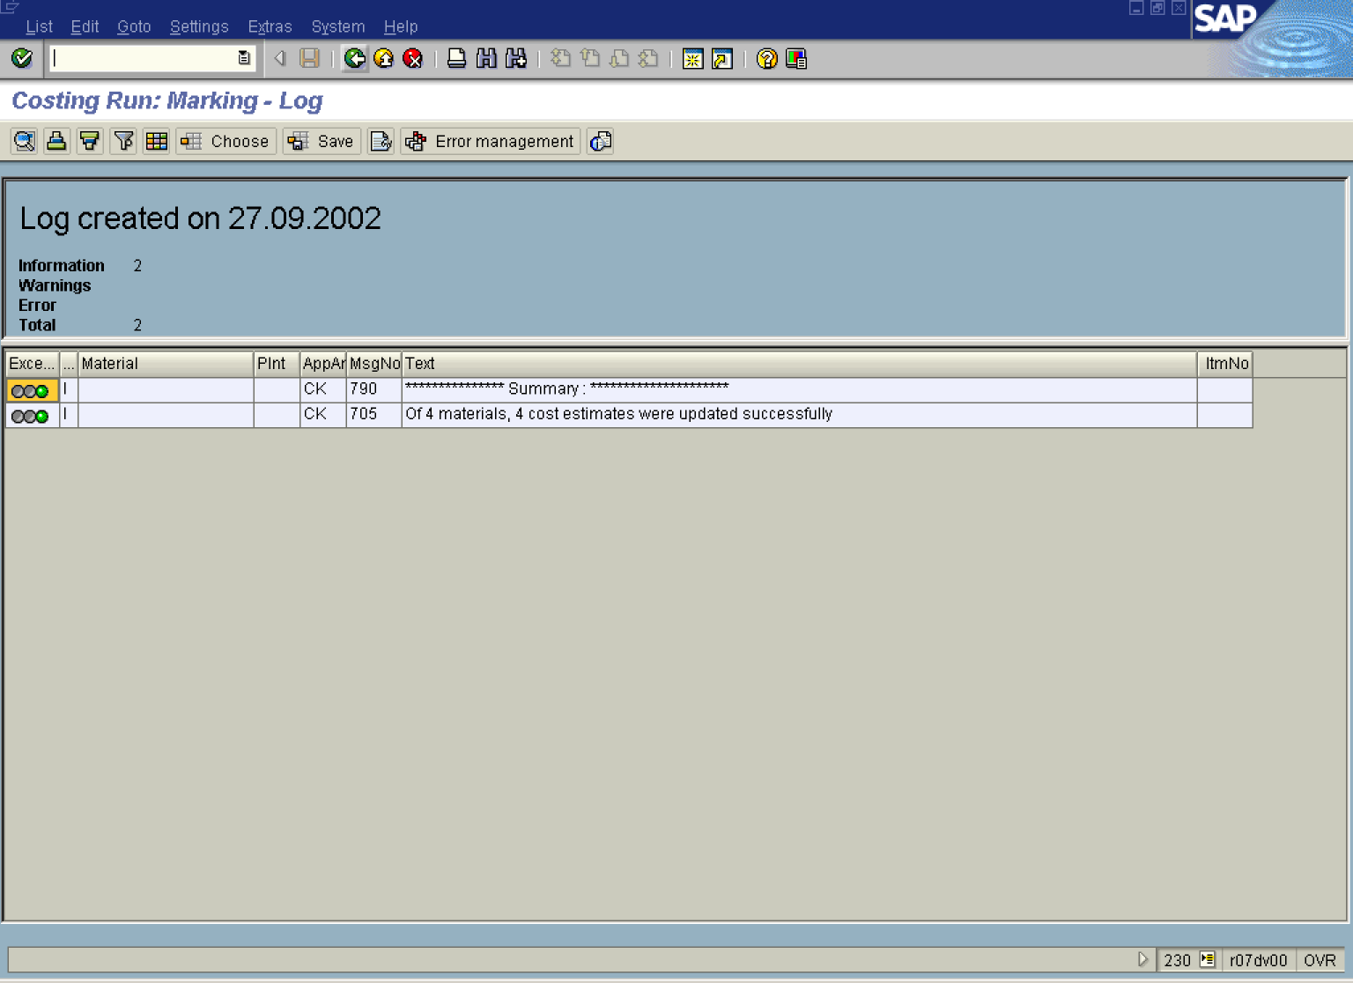

53. Click the Back button.
Edit Costing Run

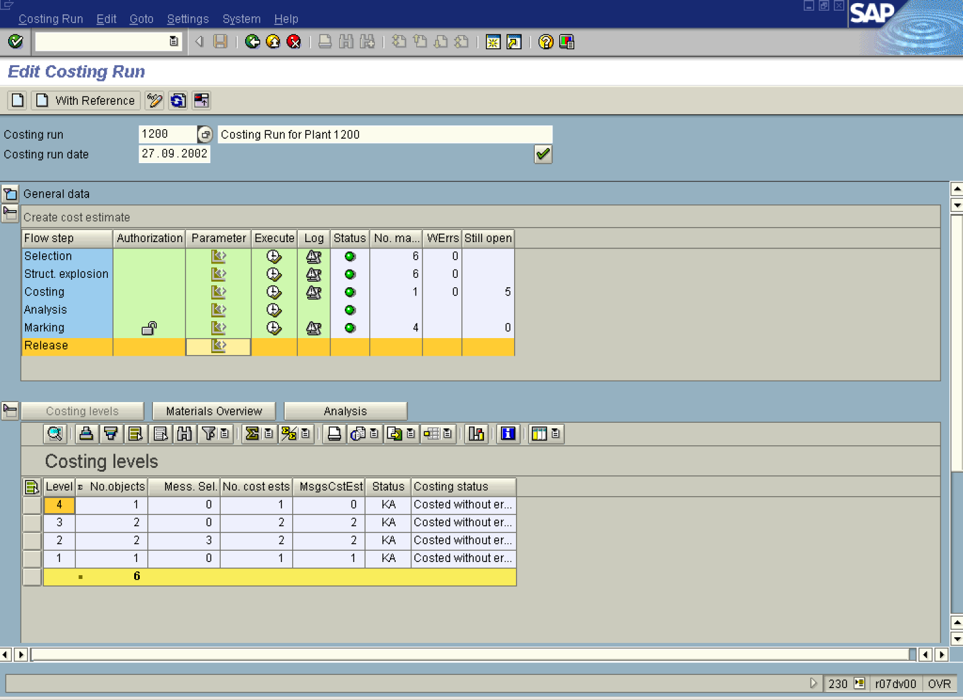

54. Click the Release Parameter button.

Price Update: Release Standard Price

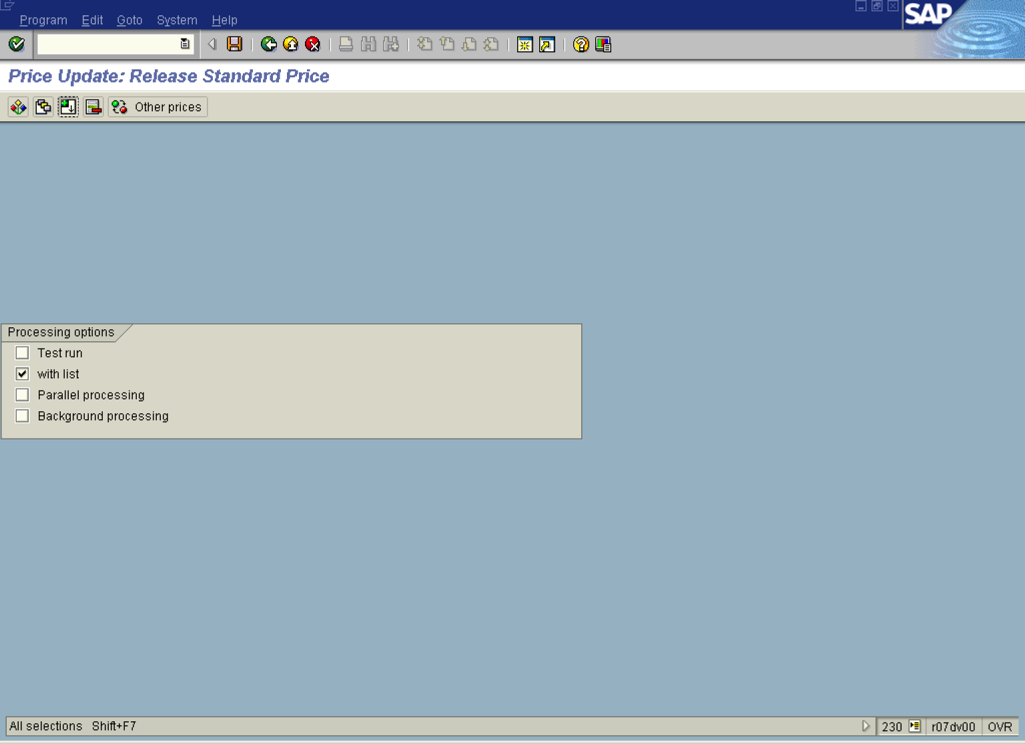

55. Click the Test run button to deselect.

56. Click the Background processing to deselect.

57. Click the All selections button.

Costing Run: Release - Change Parameters

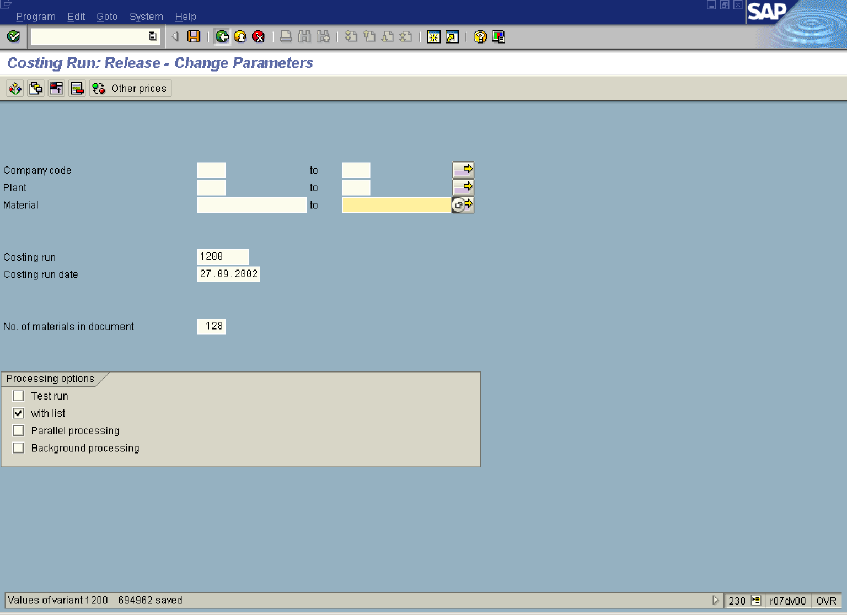

58. Click the Save button.

59. Click the Back button.

Edit Costing Run

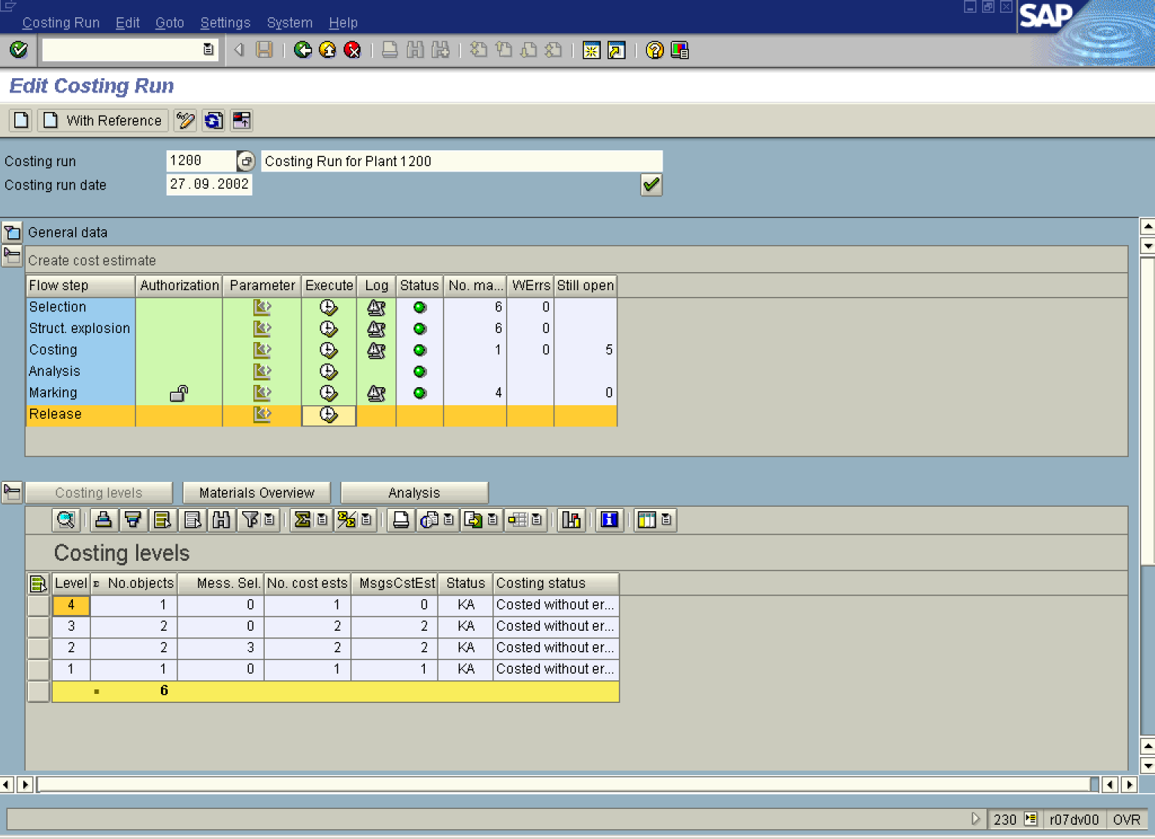

60. Click the Release Execute button.

Price Update: Release Standard Price

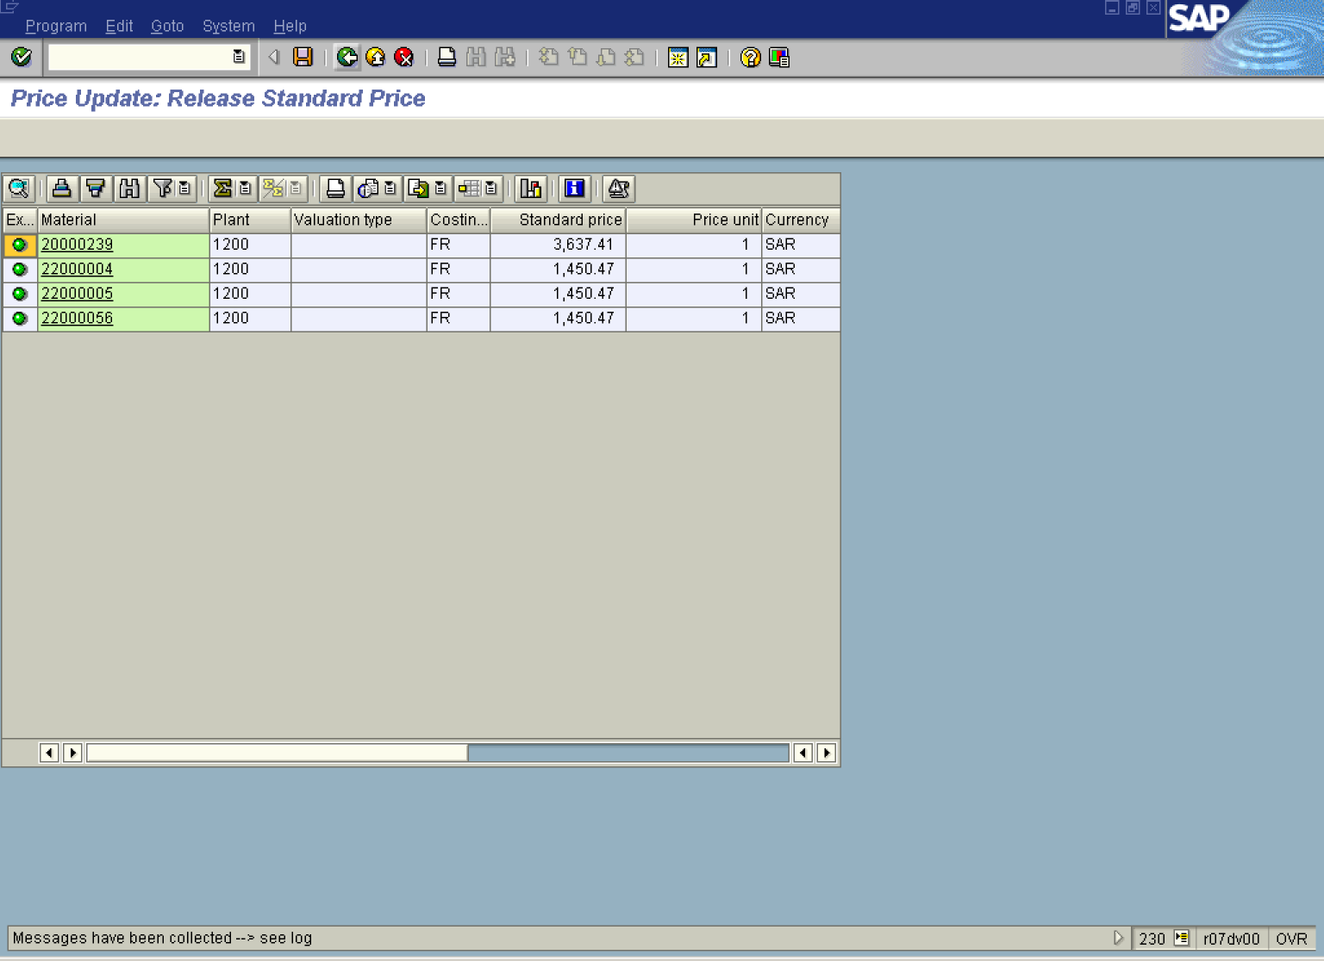

61. Click the Back button.
Edit Costing Run

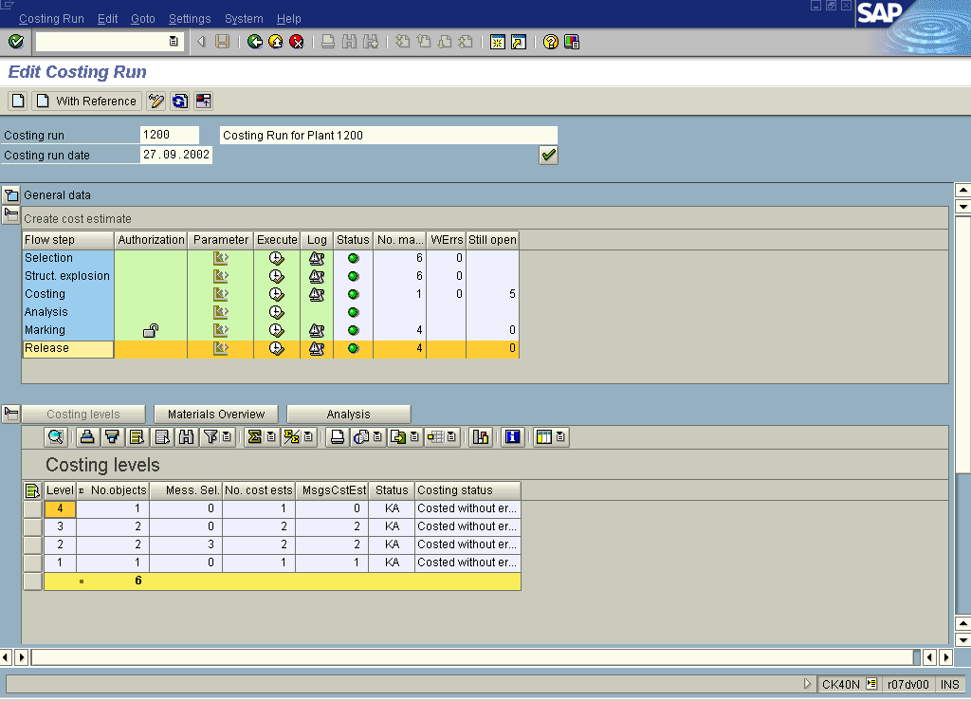

62. Click the Materials Overview button.

Edit Costing Run

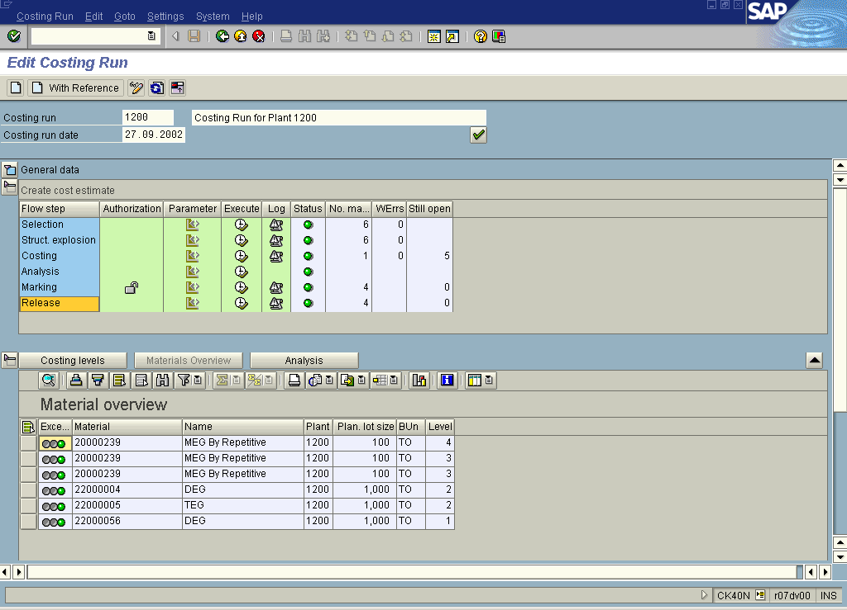

63. Click the Analysis button.

Edit Costing Run

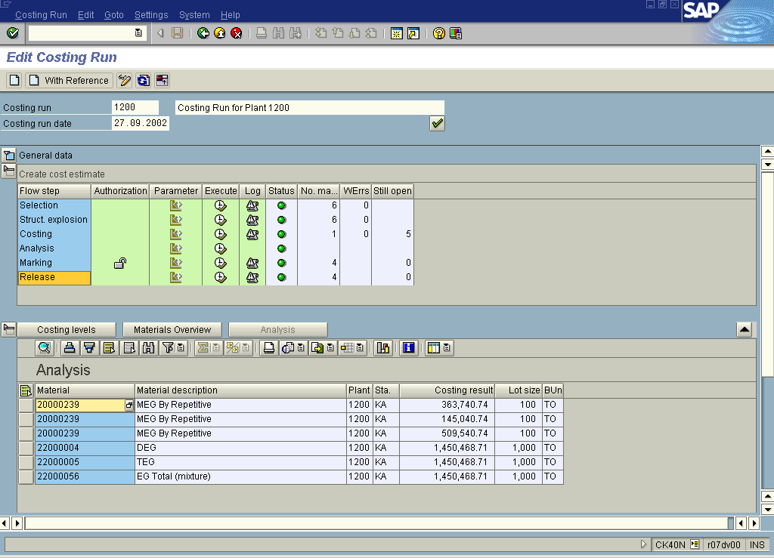

Note: To display detailed reports for costed materials, i.e. itemization, cost components, etc. select the particular material and click the Goto button.

64. Click the Back button.

Edit Costing Run

65. Click the Back button.

Edit Costing Run

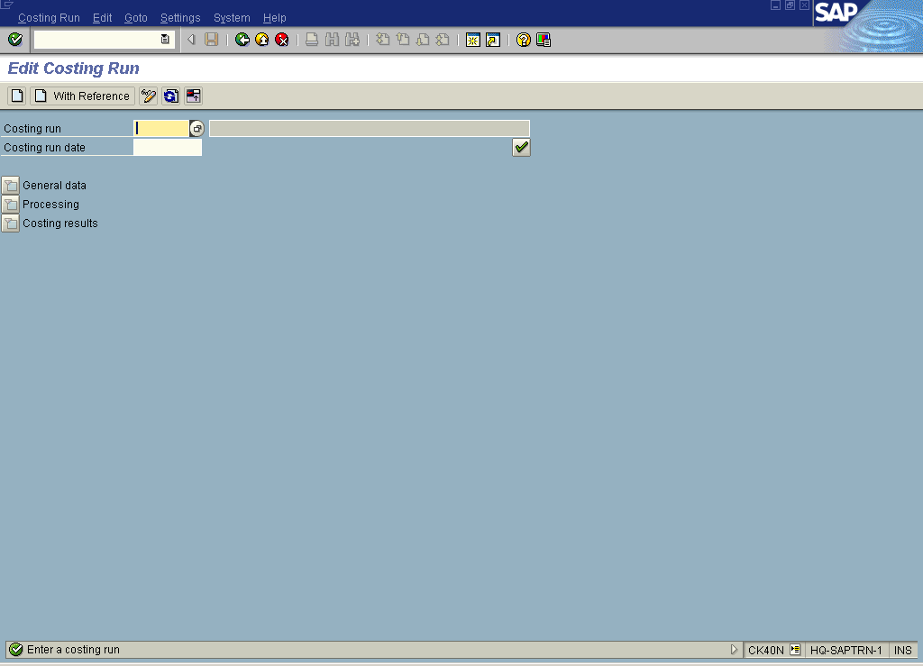

66. Click the Back button to go back to SAP Easy Access screen.

